Guidelines for poster presentation
“7th MEMTEK International Symposium on Membrane Technologies and Applications” 17-19 October 2023, Istanbul, TÜRKİYE

As a poster presenter, we would like to inform you about the details concerning the presentation of your poster at the conference.

Presentation
- Each poster presentation will have a poster ID number.
- The poster ID number will be placed at the top of the display board.
- The poster boards will be portrait and the sizes of the boards will be: 85 cm x 100 cm.
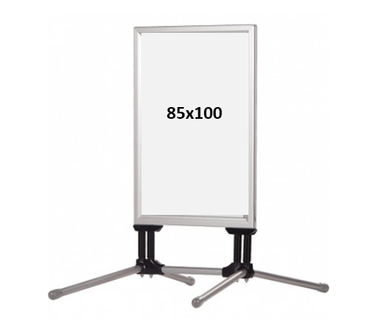
- During the conference, participants will have the opportunity to visit the poster presentations.
- Please print out your posters before you’ve come to the symposium hall.

